Inserting and Removing List Items

Look at this code:
kit = ["coat", "water", "torch"]
kit.insert(1, "map")
kit.remove("coat")
print("Packed kit:", kit)

What do you think this code will display?
Click or tap here to enter text.

Run the code. Compare the result with your prediction:
Click or tap here to enter text.

Let’s investigate! Answer the questions below:
- Why does insert() take a position first but remove() takes a stored value?
Click or tap here to enter text.

- What happens if remove() is given a value that is not in the list?
Click or tap here to enter text.

- After map is inserted and coat is removed, what exact list is printed and which position contains map?
Click or tap here to enter text.

Click or tap here to enter text.

Inserting and Removing List Items

Look at this code:
kit = ["coat", "water", "torch"]
kit.insert(1, "map")
kit.remove("coat")
print("Packed kit:", kit)

Use the code above to help you. After completing each challenge below, run your program to test that it works correctly. Save each completed challenge program in a new file.

Programming Challenges

Challenge 1
Insert "snack" at position 2 and keep the removal of coat. The final order must be water, snack, torch.
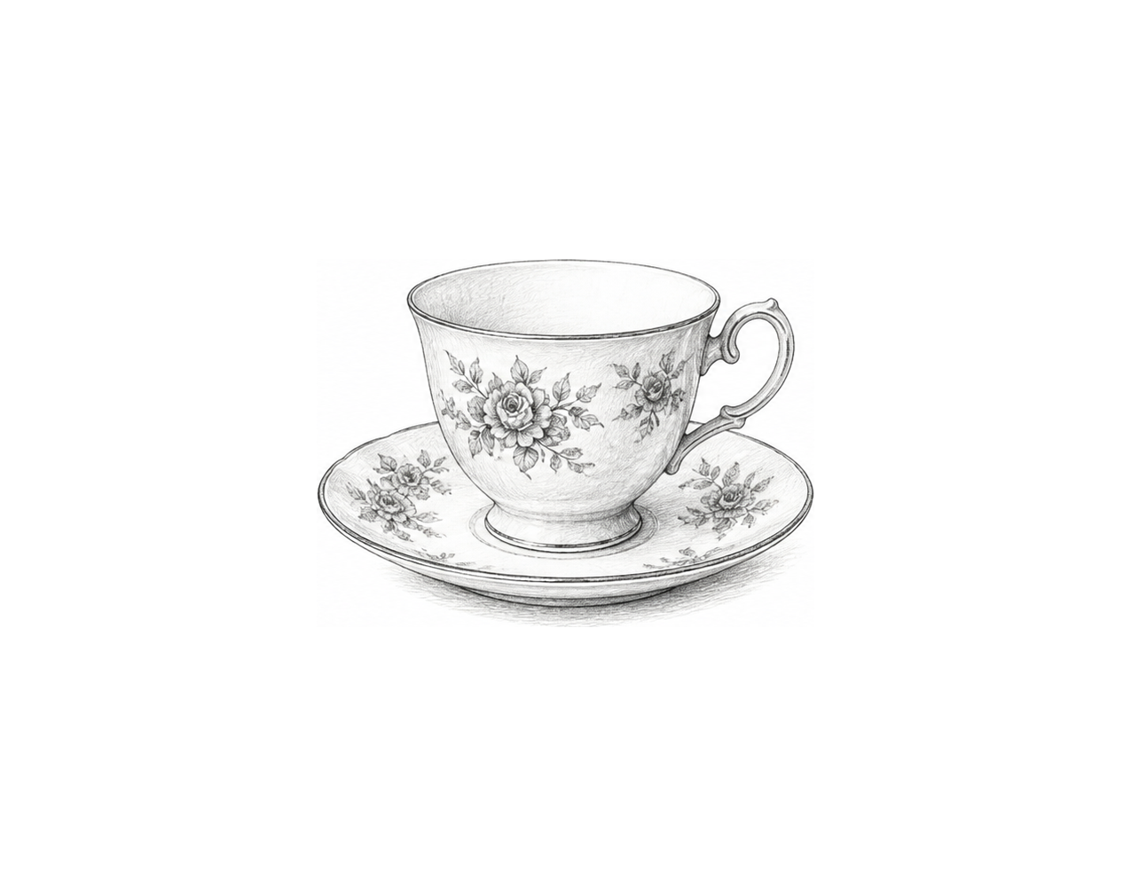

Challenge 2
Ask for an item to insert at position 1, then ask for an existing item to remove. Display the list after each operation. Test map then coat.

Challenge 3
Create a four-name running order editor. Insert a reserve at a user-chosen valid position, remove one known existing name by value, and display the final order one name per line using a for loop.

Inserting and Removing List Items

Fix the code!

This code has errors! Look closely at the code to find the problems:

kit = ["coat", "water", "torch"]
kit.insert("map", 1)
kit.remove(0)
print(kit)

Rewrite the whole program in the box below with fixes to the errors.
Click or tap here to enter text.

After you are confident that you fixed all the errors, copy the code from the box and run it.

Did it work correctly on your first try? Did you find all the errors?
Click or tap here to enter text.

